**Slovakia: new financial incentive for companies involved in dual VET**

/var/folders/nj/m875g2tj2j50hjqpdb11s_540000gn/T/com.microsoft.Word/WebArchiveCopyPasteTempFiles/national_news_on_vet_copy.png

**Companies involved in dual VET are entitled to a new financial benefit, the so-called**[**direct payments**](https://www.justice.gov.sk/PortalApp/Handlers/StiahnutPrilohu.ashx?IdPriloha=188534)**, valid since the 2018/19 school year.**

Provision of direct payments is based on a State aid scheme aiming to support dual education. It is designed by the education ministry and managed by the State Institute of Vocational Education. Its main objective is to stimulate the involvement of companies, mainly SMEs and small traders, in dual VET. Learners in SMEs receive a maximum payment of EUR 1 000 per capita. Learners in large companies completing over 400 hours of training receive EUR 700, while learners in large companies completing between 200 and 400 hours of training receive EUR 300. Direct payments cover 50% to 70% of the eligible real costs per learner, depending on the size of the company and whether it is training disadvantaged learners. A total of 60 companies received 60% coverage of their eligible real costs and 155 received 70% coverage. The total estimated amount of this State aid for the years 2019-22 is EUR 20 073 000, out of which EUR 11 501 000 will go to large companies and EUR 8 572 000 to SMEs.

In January 2019, 268 companies registered in the payment system to become eligible to claim part of the training costs of dual VET trainees. However, only 250 of them applied for reimbursement and 215 received it.

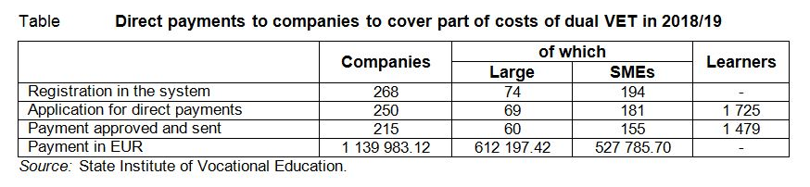

**Practical training in secondary VET**

The practical component of secondary VET programmes is provided in the following three forms:

* in school workshops in school-based VET programmes;
* in a school and a company/companies based on a training contract (mixed scheme);
* in a school and a company based on a learning contract between an individual student and the company, complemented by an institutional contract between the school and the company described in detail by legislation (dual VET).

**Companies**

Three interesting questions will need to be answered in the future. Will this instrument stimulate SMEs to participate in dual VET? Will this instrument lead to an increase in the number of dual VET learners? Will the quality of graduates from dual VET be substantially higher compared to non-supported mixed scheme graduates to justify these additional financial incentives?